

Japan-in-a-Suitcase
Teacher Materials

Daily Life in Japan

Daily Life in Japan

Presentation Agenda

- PowerPoint Presentation (15 minutes)
  - Greeting and self-introduction
  - General information about Japan
  - Practice some Japanese greetings
  - Show pictures of a Japanese house

- Activities (30 minutes)
- Chopsticks manners
- Create a design on chopsticks
  - Tea ceremony manners

- Closing (5 minutes)
  - Q and A
  - Practice “Good-bye” in Japanese

Japanese Greetings and Words

Good morning = おはよう＝ Ohayo (Oh-hah-yoh) Sounds like Ohio!
Hello, Hi = こんにちは= Konnichiwa (Kohn-nee-chee-wah)
Thanks = ありがとう= Arigato (Ah-ree-gah-toh)
Good Bye = さようなら= Sayonara (Sah-yoh-nah-rah)
Let’s eat! = いただきます= Itadakimasu (Ee-tah-dah-kee-mahs)

Let’s introduce yourself in Japanese!
My name is ____________.
Watashi no namae wa ____________ desu.
わたしのなまえは ____________です。
(Wah-tah-shee noh nah-mah-eh wah ___________ dess.)
I am ____________.
Watashi wa ____________ desu.
わたしは ____________です。
(Wah-tah-shee wah _____________ dess.)
- A student = Gakusei (gah-koo-say)
- An American person = Amerika-jin (ah-meh-ree-kah-jeen)
- A Japanese person = Nihon-jin, Nippon-jin (nee-hohn-jin, neep-pohn-jin)
Nice to meet you.
Yoroshiku onegai shimasu.
よろしくおねがいします。
(Yoh-roh-shee-koo oh-neh-guy shee-mass.)
Japanese Chopsticks Manners

Basics: How to Hold Chopsticks:
- Hold the upper chopstick with the index finger, the middle finger, and the thumb.
- Put the other chopstick between the bottom of the thumb and the tip of the ring finger.
- Move the upper chopstick only when you pick up food.

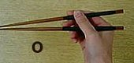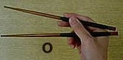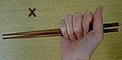

Bad manners:
- Waving chopsticks above food dishes.
- Sticking chopsticks into food instead of picking them up.
- Picking up a cup/bowl with the hand that is holding your chopsticks.
- Sucking chopsticks.
- Sticking chopsticks vertically into a bowl of rice.
- Passing food from your chopsticks to somebody else's chopsticks.
How to Pick Up Chopsticks:
- Pick up chopsticks by the thumb, the index fingers, and the middle fingers.
- Support the chopsticks by the other hand.
- Hold the chopsticks properly.
Extra Tip:
When you finished using disposable chopsticks (wari-bashi), put them back in the bag and fold the bag in half. This indicates that they are used.

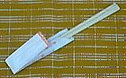
Enjoy Japanese meals!
Japanese Tea Ceremony

The tea ceremony (Sado: "the way of the tea") is a ceremonial way of preparing and drinking tea. Nowadays, the tea ceremony is a relatively popular hobby. Many Japanese who are interested in their own culture take tea ceremony lessons. Tea ceremonies are held in traditional Japanese rooms in cultural community centers or private homes. The ceremony itself consists of many rituals that have to be learned by heart. Almost each hand movement is controlled. Basically, the tea is first prepared by the host, and then drunk by the guests. The tea is bitter Matcha green tea made of powdered tea leaves.

Tea was originally brought to Japan in the 9th century from China. Around the end of the 12th century, a style of tea preparation was introduced by a Buddhist monk returning from China that allowed the lower classes to enjoy the once-expensive drink. By the 16th century, tea drinking had spread to all levels of society in Japan. Sen no Rikyu, perhaps the most well-known—and still revered—historical figure in tea ceremony, followed his master’s, Takeno Jōō's, concept of ichi-go ichi-e, a philosophy that each meeting should be treasured, for it can never be reproduced. His teachings perfected many newly developed forms of Japanese architecture and gardens, fine and applied arts, and the full development of Sadō, "the "way of tea". The principles he set forward—harmony, respect, purity, and tranquility—are still central to contemporary tea ceremony.
- Wa: Stands for harmony. As there is harmony in nature, the tea ceremony is the way of bringing about a harmonious relationship with others.
- Kei: Stands for respect. The guests must respect all things and all matters without involving their status or position in life.
- Sei: Stands for purity. The tea room is a different world and we are to leave behind all thoughts and worries of daily life.
- Jaku: Stands for tranquility. Only after the first three concepts are experienced may people finally embody tranquility.

Japanese Tea Ceremony Procedures
The tea ceremony is a very special event in Japanese culture. The host spends days going over every detail to make sure that the ceremony will be perfect. There are various styles of tea ceremonies, so preparations may differ. It is recognized that every human encounter is a singular occasion that will never recur again in exactly the same way, so every aspect of the tea ceremony is savored. As a host, the steps to the ceremony can be quite simple: clean the serving bowls, boil a pot of water, serve a sweet treat to guests before the tea, mix powdered bitter green tea (Matcha) and water to make a frothy drink, serve the tea to guests. The flavors of the sweets and bitter tea complement each other. This is a symbol of harmony.
- Bow and say ”Itadakimasu” when you receive the cup of tea, or chawan.
- Take the chawan with your right hand and place it in the palm of your left hand.
- Turn the chawan clockwise three times before you take a drink.
- When the tea is gone, make a loud slurp to tell the host that the tea was truly enjoyed.
- Wipe the part of the chawan that your lips touched with your right hand.
- Turn the chawan counterclockwise and return it to the host.

For more information about Japanese Tea Ceremony, please go to http://www.japanese-tea-ceremony.net/

Japanese National Holidays

January 1: New Year (shogatsu)
This is the most important holiday in Japan. While only January 1 is designated as a national holiday, many businesses remain closed through January 3.
Second Monday of January: Coming of Age Day (seijin no hi)
The coming of age of 20 year old men and women is celebrated on this holiday.
February 11: National Foundation Day (kenkoku kinenbi)
According to the earliest Japanese history records, on this day in the year 660 BC the first Japanese emperor was crowned.
March 21: Spring Equinox Day (shunbun no hi)
Graves are visited during the week (ohigan) of the Equinox Day.
April 29: Showa Day (Showa no hi)
The birthday of former Emperor Showa. Before 2007, April 29 was known as Greenery Day (now celebrated on May 4). Showa Day is part of the Golden Week.
May 3: Constitution Day (kenpo kinenbi):
A national holiday remembering the new constitution, which was put into effect after the Second World War.
May 4: Greenery Day (midori no hi)
Until 2006, Greenery Day was celebrated on April 29, the former Emperor Showa's birthday, due to the emperor's love for plants and nature. It is now celebrated on May 4 and is part of Golden Week.
May 5: Children's Day (kodomo no hi)
The Boy's Festival (Tango no Sekku) is celebrated on this day. Families pray for the health and future success of their sons by hanging up carp streamers and displaying samurai dolls, both symbolizing strength, power and success in life.
Third Monday of July: Ocean Day (umi no hi)
A recently introduced national holiday to celebrate the ocean. The day marks the return of Emperor Meiji from a boat trip to Hokkaido in 1876.
Third Monday of September: Respect for the Aged Day (keiro no hi)
Respect for the elderly and longevity is celebrated on this national holiday.
September 23: Autumn Equinox Day (shubun no hi)
Graves are visited during the week (ohigan) of the Equinox Day.
Second Monday of October: Health and Sports Day (taiiku no hi)
On this day in 1964, the Olympic games of Tokyo were opened.
November 3: Culture Day (bunka no hi)
A day for promotion of culture and the love for freedom and peace. On Culture Day, schools and the government award certain persons for their special cultural activities.
November 23: Labor Thanksgiving Day (kinro kansha no hi)
A national holiday for honoring labor.
December 23: Emperor's Birthday (tenno no tanjobi)
The birthday of the current emperor is always a national holiday. If the emperor changes, the national holiday changes to the birth date of the new emperor.

- If a national holiday falls on a Sunday, the following Monday will also be a holiday.
- If a day lies between two national holidays, the day will also be turned into a holiday.
Sports in Japan
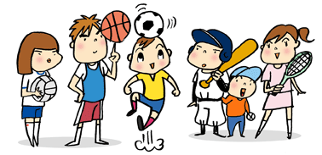

1) What sports are played in Japan today?
Baseball remains the nation's best-attended spectator sport, and the annual national high school championships are hugely popular among the Japanese. Like Major League Baseball in the United States, Nippon Professional Baseball (NPB) has two leagues: the Central and the Pacific. Japan's oldest and most popular team, the Yomiuri Giants from Tokyo, compete in the more popular Central League. The baseball season consists of 140 games, ending with the Japan Series Championship. Soccer has rapidly increased in popularity. Japan co-hosted the 2002 FIFA World Cup, the first time the tournament was held in Asia. Japan's professional soccer league, the J. League (Japan League), began in 1993 and has 33 teams. The ancient sport of sumo also remains popular. Athletes from all over the world compete among the top wrestlers. There are six sumo basho (tournaments) each year. Golf is also a very popular social sport in Japan.

2) What are Japan's traditional sports (including martial arts)?
Perhaps the best-known traditional Japanese sport is sumo wrestling. The origins of sumo can be traced as far back as the Fifth Century, and is generally considered the national sport. The highest rank in sumo is that of yokozuna, of whom there are currently only two: Asashoryu and Hakuhosyo (both from Mongolia). The fighting arts of the samurai developed during the Edo Period (1603-1868) into many different schools of martial arts. Japan's famous martial arts include judo, kendo, kyudo, and naginata – among others. The practice of ranking skill levels by belt (obi) originated in judo. Japanese fencing, known as kendo, is believed by some to be linked with the spirit of Japan. Kyudo, or Japanese archery, utilizes a long bow
made of bamboo and is popular in high schools and universi
ties. Naginata, using the curved sword halberd, developed
mainly as a martial art for women in warrior families. Karate
was brought to Okinawa from China and is popular among
students. Martial arts typify the spirit and religious influences of
Zen Buddhism and Shinto in Japan.
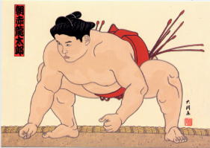

3) Who are some famous Japanese athletes?
Kosuke Kitajima from Tokyo is a Japanese multiple Olympic gold medalist breaststroke swimmer. He won gold medals for the men's 100m and 200m breaststroke at both the 2004 Athen and 2008 Beijing Olympics. He competed in the 2012 London Olympics.
Nadeshiko Japan or the Japan women's national football (soccer) team is a selection of the best female players in Japan. They defeated the U.S. in the 2011 FIFA Women's World Cup Final, becoming the first Asian team to win the FIFA Women's World Cup.
Yu Darvish from Osaka is a Persian-Japanese right-handed starter pitcher for the Texas Rangers. Before joining MLB in 2012, Darvish played for professional Japanese teams for over six years and pitched for the Japanese teams in the 2008 Beijing Olympics and 2009 World Baseball Classic. Many considered him the best NPB pitcher.

Book Recommendation

Hachiko Waits

Author – Leslea Newman
Illustration – Machiyo Kodaira
Published – Fall 2004
Grade - 3rd - 5th

Hachi walks with his master to the train station every day, goes home, and comes back to the station to meet his master's train when he returns from work. But one day his master doesn't return. Hachi goes home and comes back to meet the train every day for many years. His loyalty and devotion touch the heart of the Japanese people and change the life of a young boy named Yasuo forever. Based on the true story of the famous Akita who lived in Shibuya, Japan from 1923-1935, this is a must-read for dog lovers of all ages.



Useful Websites

Teachers:
www.jnto.go.jp
Excellent teacher resource. Contains information on geography, language, population, history, culture, tradition, events, amusement, food, etiquette, current events and more. Also Supports wonderful photo galleries.

http://www.askasia.org/teachers/
Many resources for teachers teaching Asian subjects grades K-12, including lesson plans and current essays on Asian culture.

http://aboutjapan.japansociety.org
New interactive website for educators, featuring lesson plans, essays and annotated hands-on material for in-class use.

http://www.japantimes.co.jp/
The Japan Times is a free news source that offers many resources for both teachers and students about modern Japan.

www.bento.com
Information on food (food culture, recipes, and what’s new in Japanese restaurants for select areas.

http://spice.stanford.edu/docs/147
Annotated lists of recommended websites about Japan arranged by topic. Provided by the National Clearinghouse for U.S.–Japan Studies

Students:
http://jguide.stanford.edu/
Ultimate guide to finding resources on a specific topic of Japan. Has currency converter, current time, and news and media in Japan. Great for teachers and students exploring culture

http://www.tjf.or.jp/thewayweare/index.html
A site dedicated to sharing the lives of Japanese High School students with their peers oversees through pictures and stories.

http://www.origami-club.com/en/
Lots of origami ideas with animated instructions

http://web-japan.org/kidsweb/
Fun interactive activities and the latest “cool” things from Japan

Map of Japan
http://worldatlas.com/webimage/countrys/asia/jp.htm
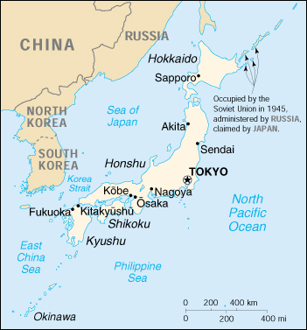

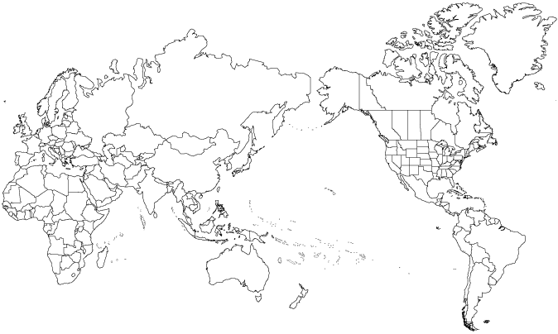

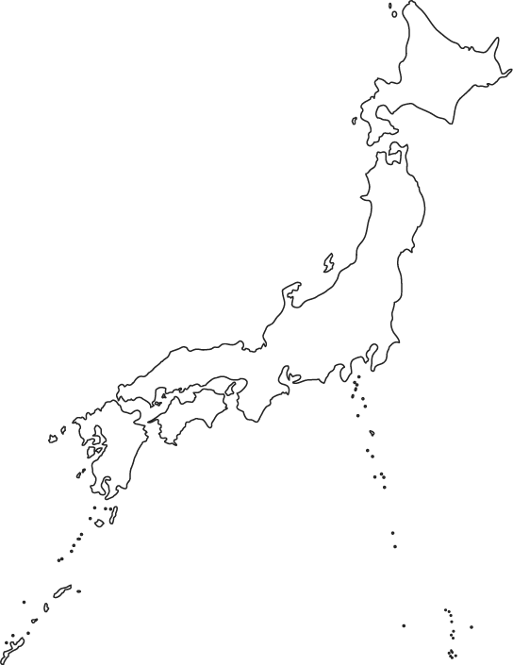
Japan
http://worldatlas.com/webimage/countrys/asia/jp.htm

