Red River Historian
Press * Presentations * Art
____________________________________________________________________________________________________

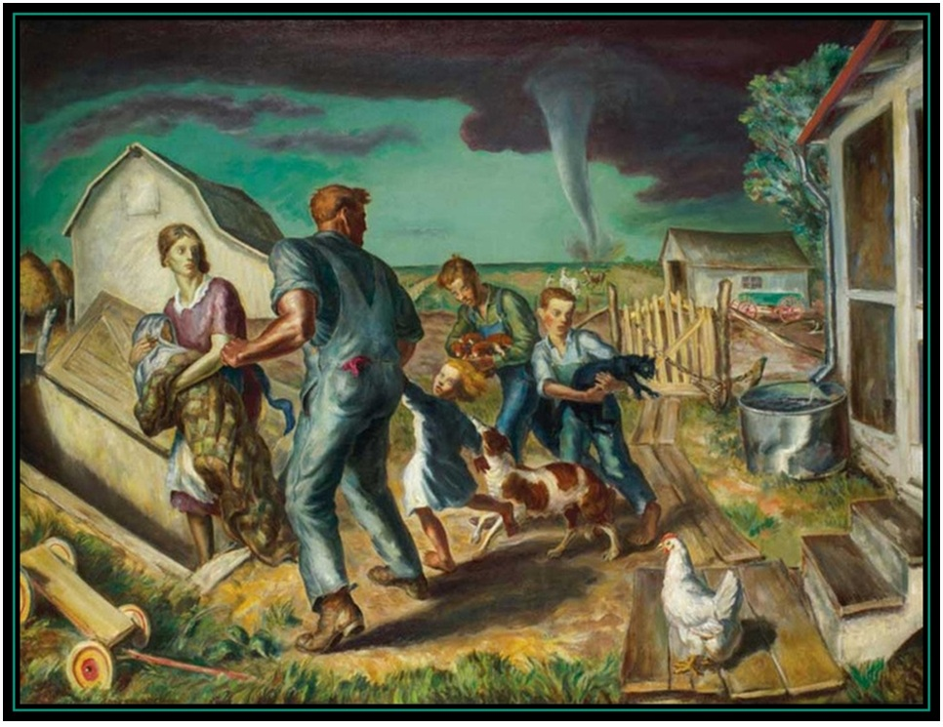

Program title:
Public Art from the WPA

Program Description:
The Works Progress Administration, which began in 1934 as a component of Franklin Delano Roosevelt’s second “New Deal,” proved to be one of the most successful programs during the Great Depression. The project employed thousands of writers, teachers, photographers, designers, thespians, and artists, ultimately creating a kaleidoscope of American culture that has not been duplicated since. In this presentation, students will explore the history of the program and examine the contributions from a variety of professionals, including posters, murals, photographs, recipes, travelogues, and life stories.

Presenter Information
Robin Cole-Jett possesses a Master of Education in Secondary Education and a Master of Arts in History. She teaches US History at a local junior college, consults and creates educational materials for the Texas Historical Commission, conducts tours on Bonnie and Clyde, and gives presentations for museums, affinity groups, schools, and senior citizen centers throughout the region. Her website, www.redriverhistorian.com, has allowed her to share regional history with many like-minded individuals. She has authored four books on the history of the “Old Southwest” and is currently writing a fifth “Traveling History Guide” about Ghost Towns in the Red River Valley.

Art Component:
The teacher can choose which art components to include with the presentation. Please note that appropriate component inclusion will depend on the amount of time allotted to the presentation.
- Students will identify artists and styles associated with the WPA.
- Students will critically assess subject matter through photographic selections.
- Students will create their own “guides” that can include family stories and recipes. They can illustrate this through photographs and/or artwork.
- Students will create posters with public service announcements that is relevant to the time period of the Great Depression as well as today.
- Students will evaluate peers’ artworks based on their own interpretations.

Subject matter:
US History during the Great Depression and New Deal; Texas history; cultural history; economics; creative expression; historical/cultural heritage; professions in the field of Arts.

Grade levels:
5th grade art and social studies and 8th grade art

TEKS
5th grade Fine Art
  - Perception. The student develops and organizes ideas from the environment.
5.1 a – communicate ideas about feelings, self, family, school, and community, using sensory knowledge and life experiences
5.2 Creative expression. The student expresses ideas through original artworks, using a variety of media with
appropriate skill.
5.2 a – combine information from direct observation, experience, and imagination to express ideas about
self, family, and community.
5.2 b – compare relationships between design and everday life
5.2 c – create original artworks and explore photographic imagery, using a variety of art materials and media appropriately.
5.3 Historical/cultural heritage. The student demonstrates an understanding of art history and culture.
5.3 a – compare artworks from a national period
5.3 b – compare cultural themes honoring history and traditions in American artworks
5.3 c – identify the use of art skills in a variety of jobs
5.4 Response/evaluation. The student makes informed judgments about artworks.
5.4 a – analyze personal artworks to interpret meaning
5.4 b – analyze original artworks, portfolios, and exhibitions by peers and others to form conclusions

5th grade Social Studies
5.5 (History) The student understands important issues, events, and individuals in the United States during the 20th and 21st centuries. The student is expected to:
5.5 a – analyze various issues and events of the 20th century such as the Great Depression
5.7 (Geography) The student understand the concepts of regions in the United States. The student is expected:
5.7 a – describe a variety of in the United States such as political, population, and economic regions that result from patterns of human activity
5.12 (Economics) The student understands the impact of supply and demand
5.12 a – explain how supply and demand affects consumers in the United States
5.12 b – evaluate the effects of supply and demand on industry and agriculture
5.13 (Economics) The student understands patterns of work and economic activities in the United States.
5.13 a – compare how people in different parts of the United States earn a living, past and present
5.13 c – analyze the effects of migration and limited resources on economic development and growth
5.21 (Culture) The student understands the relationship between the arts and the times during which they were
created.
5.21 b – explain how examples of art, music, and literature reflect the times during which they were created.
5.22 (Culture) The student understand the contributions of people of various racial, ethnic, and religious groups in the United States.
5.22 b – describe customs and traditions of various racial, ethnic, and religious groups to our national identity.

8th grade Fine Art
8.1 Perception. The student develops and organizes ideas from the environment.
8.1 a – illustrate ideas from direct observation and personal experiences incl. school and community
8.1 b – define a variety of concepts directly related to the art elements and principals, using vocabulary
accurately.
8.2 Creative expression. The student expresses ideas through original artworks.
8.2 a – create artworks integrating themes found through direct observation, personal experiences
8.2 b – apply design skills to communicate effectively ideas and thoughts in every day life
8.3 Historical/cultural heritage. The student demonstrates an understanding of art history and culture as records
of human achievement.
8.3 b - identify cultural ideas expressed in artworks relating to social, political, and environmental themes
8.3 c – survey career and avocational opportunities in art
8.4 Response/evaluation. The student makes informed judgments about personal artworks and artworks from
others.
8.4 a – analyze with teacher or peers personal artworks in progress
8.4 b – analyze original artworks and exhibitions

Duration
One to two hours

Includes
Slideshow (PowerPoint) from presenter
Handouts & lesson plans for teachers
Historical artifacts relating to presentation that students can examine, touch, and discuss
Art supplies: Paper, crayons, colored pencils, oil pastels
Needs
Projector for Power Point Presentation (I will bring my own equipment if necessary)

Venues
In school: in class and in auditoriums
After school programs

Cost
- For small groups (up to 50 students) - $225.00, $85 for additional presentations booked back-to-back on the same day

